# Sign up

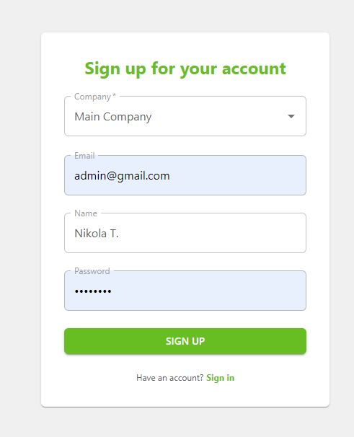

* Select your company, enter your email, name and password and Click Sign Up.
* User is not activated at the time of signup. New users should contact the admin(The owner of the website) to activate their user.
* Once activated, users can sign in to the website using their email and password.

# Sign in

* Enter your email and password to sign in to the website.

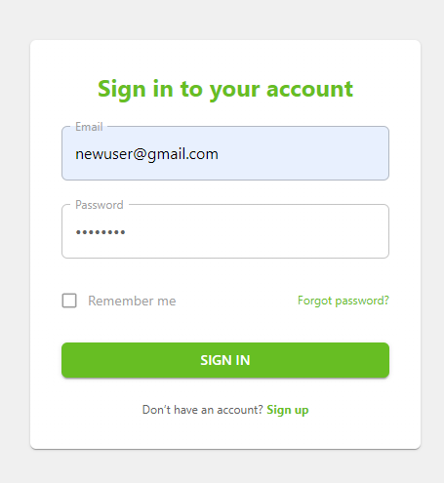

# User Management(Admin Only)

When a user’s role is set to admin, he/she can manage users.

Admin can change user’s name, email, company, role and activate the user.

Also admin can delete an existing user.

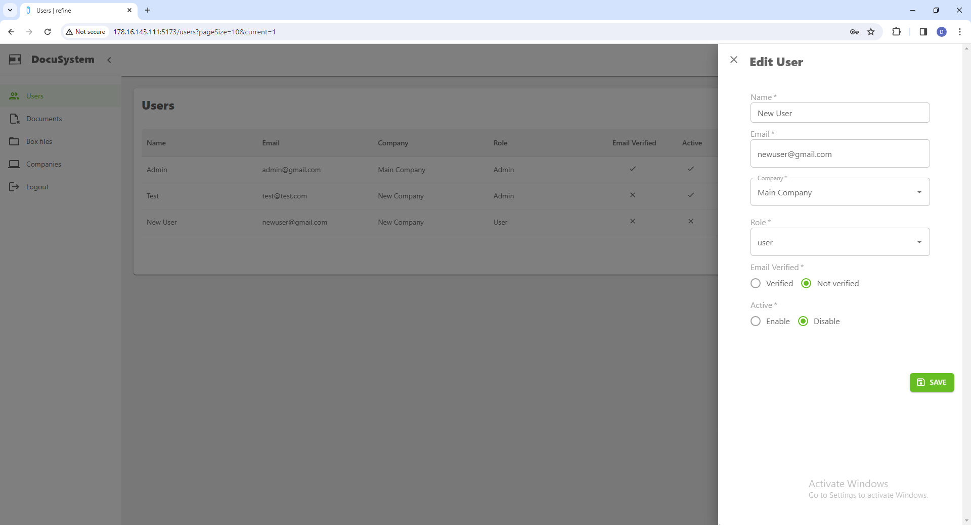

1. Company Management(Admin Only)

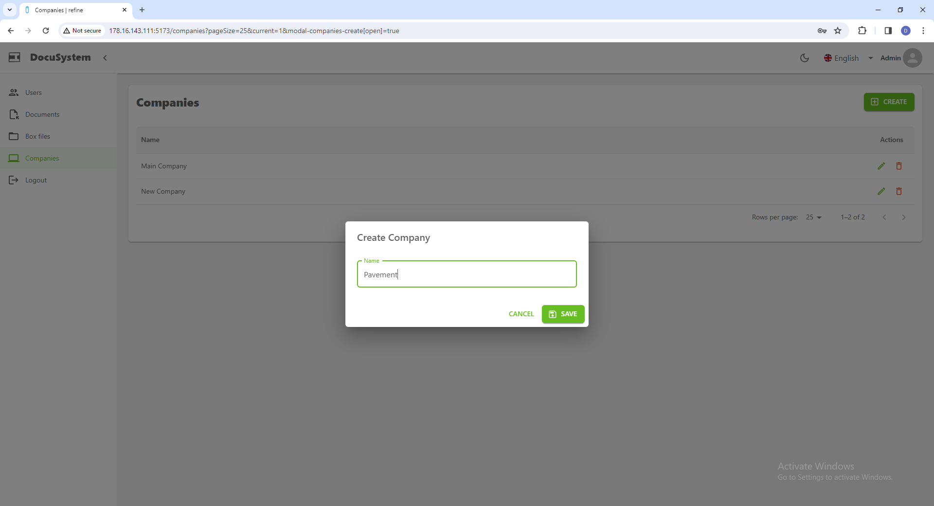

Admin user can manage companies.

Admin can create, edit or delete companies.

Every user belongs to one company and he is allowed to manage the documents and box files of his own company.

1. Box Management

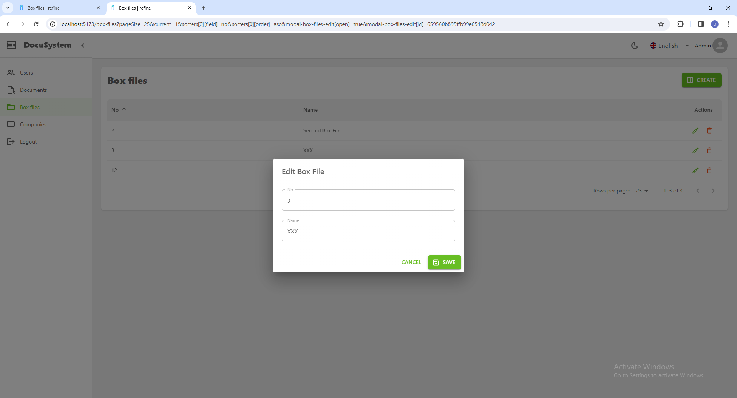

Box Files are group of documents each of which has Name and No.

Users can create, delete or edit the name and no of box files which belong to his company.

1. Document Management & Search

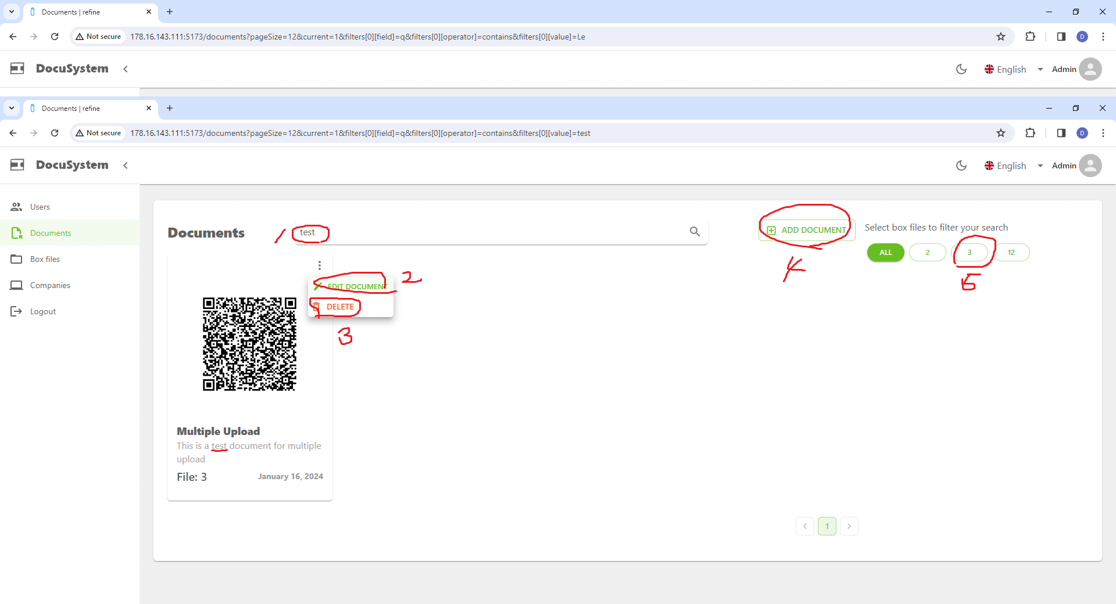

* Users can search for documents with name or title containing the query string(1).
* Edit document by clicking “Edit Document”(2) button or create a new document by clicking “Add Document“(4) button.
* You can see documents in specific box files by clicking Box File Number Buttons(5).

You can toggle Box File Selection by clicking Box File Numbers

You can reset the selection by clicking “All” Button.

* Delete Document by Clicking “Delete Document”(3)
* You can view or print the document images by clicking “Edit Document”(2) button

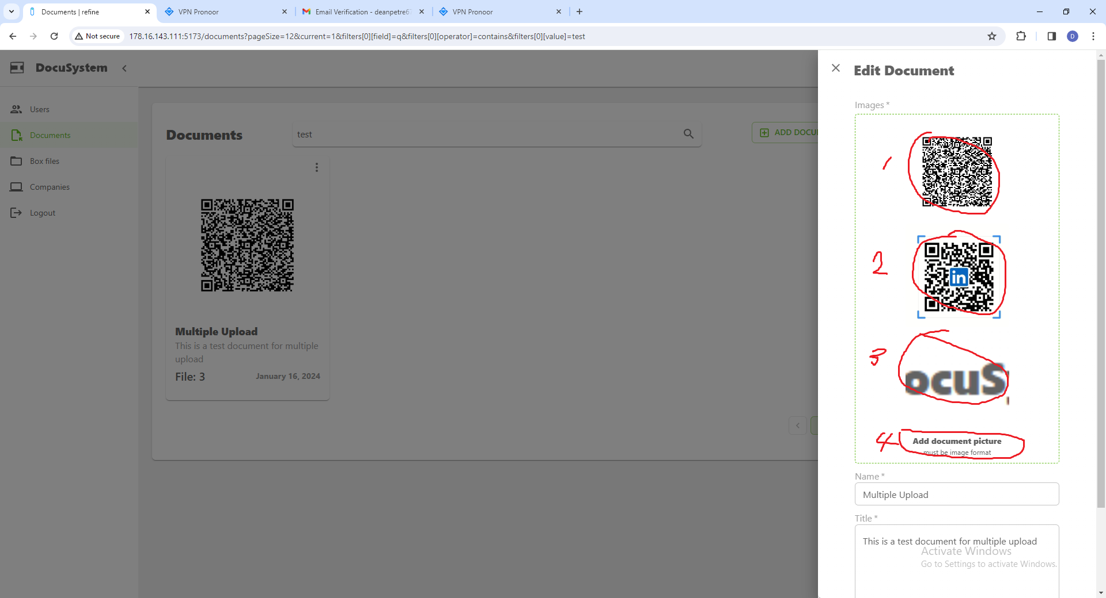

When you click region 1~3, it opens a new tab with original-sized image. You can then press Ctrl+P on your keyboard to print that image.

To add or modify the images, you should click region 4.

You can select multiple images from the dialog and click “Open”.

